**EXCESSIVE USE OF ELECTRICITY AND CO2 EMMISSIONS BY USING INTERNET !**

**Yüksel Atakan, Dr.Y.Müh. ybatakan3@gmail.com,Germany**

**GOOGLE TRANSLATION – ERROR CAN NOT BE PREVENTED**

**The electricity spent on the Internet is as much as 300 nuclear plants produce!**

**summary**

The age of digitalization and the internet is almost over. Because the amount of data and traffic in smartphone and internet use in general increases every year at a dizzying rate (exponsively). In the near future, the electricity required for internet use, which will exceed 5 billion people,will increase further **co2** to be released into theatmosphere, scientific research in developed countries shows, and countermeasures are proposed.

As we have emphasized in our previous articles, if **the population growth, comfortable life and extravagance** in the world **continues**like this , moreelectricity needed to produce everything more, while producing in power plants, it is predicted that our world will become uninhabitablein the future with **CO2** and other greenhouse gases released into theair.

When we go online with tools such as smartphones or laptops, we do not use electricity from the electrical network that we connect, only to fill them directly or theirbatteries. At the same time, we indirectly activate millions of data stored on servers, causing them to use electricity there and on the 'world internet network'. Therefore, as a result of running the servers and warming up to intensive data operations, electricity is also required to cool them down. In addition, our emails and various other data accumulated over time are stored in packages on the servers. Considering that 5 billion people are made for trillions of data packages, the size of theelectricity required to operate servers and the internet network can be estimated. In 2018, information and communication technologies (ICT)said the internetspends between 6% and 10% of the electricity used worldwide.

Today, no one is asked to give up their smartphone, tablet, laptop or PC, which is now entering our lives. However, since all these instruments use electricity, it is imperative that electricity production increase. Themajority of electricity generation is provided today in fossil fuel plants that release more **CO2** into the environment. The gap must be closed by electricity generated at fossil fuel or nuclear power **plants, as the increasing need for electricity with increased internet use is greater than the annual increase in renewable energies.** However, the number of nuclear and fossil fuel power plants in the world is increasing and under construction every year because of the increasing need for electricity and we are causing it. For example,449 nuclear plants are operating in the world in 2018 and 55 are under construction.The number of new reactors commissioned in 2018 is 9 and the electricity produced by these 9 reactors in 2018 is 10 GWe).

Therefore, we should consciously use the internet, which makes our life easier and is now our 'must-have' in allrespects, or, in short, we should not be unnecessarily extravagant here.

**Energy-swallowing Internet!**

Today, approximately 5 billion people in the world are communicating on the Internet with mobile or fixed tools. Our relationships with smartphones, tablets, PCs and other tools on email, Skype, WhatsApp, Facebook or Twitter, company video conferences, internet banking, internet shopping or searching for things on Google, sending pictures, videos, downloading and watchingmovies, as it is known, can be realized through the internet connections of countless Servers around the world. For example, when we send an e-mail to individuals or institutions at home or abroad,it is transmitted from us to the servers thousands of miles in submarinecables, with electricity. Now, in internet banking, which most of us use easily without going to the bank, data flow goes back and forth between continents, for example, when a person in the UNITED States is trading from their bank account in Turkey. Thepassword we use for the bank instantly comes toour smartphone with thousands of long cables under the sea, and when we confirm it, the data flow goes back instantly in the same way. Such processes make our lives easier today, preventing time and other losses. However, using the internet extravagantly, unnecessarily, means more electricity and more **CO2** production.

The number of searches on Google alone is3.5 trils per day. That's 40% of all searches on the Internet. **It is calculated that the**amount of CO**2** released into the air when generating the electricity required for the Internet is the amount of**CO2** produced by air traffic around **the world.**  In addition, as the servers are heated by working nonstop 24 hoursaday, much more electrical energy is required because it needs to be cooled. On the other hand, **electricity** is needed to build the increasing internet network, cables, servers and related tools and equipment, in short, **billions of instruments.**

Although exact calculations are unlikely to be made for the whole world, according to the predictions made by various scientific research centers, the Internet uses an average of 8% of the total electricity generated in the world,which means approximately 300 nuclear power plants can produce as much electricity as they can!

**If a ranking is made according to the amount of electricity used by countries for everything in the world, the internet can be compared to the 3rd most electricity-using country after China and the United States.**



Figure 1: World internet communication network (schematic)

**A theoretical calculation:**

**Assuming that all the internet networks in the world will use nuclear reactors that do not release CO2,**  **how many nuclear reactors can be supplied with the** electricity required for the Internet?

Total electrical energy produced in the world in 2017, according to the World Energy Agency (WEA)

It is 21372 TWh (or 21 372 Billion kWh) and the internet uses 8% of this or : 1710

TWh

The amount of electrical energy generated by nuclear reactors in the worldis 2563 TWh, according to the World Nuclear Organization, and is 12% of the world's total electricity generation. This amount of electricity was produced in 449 nuclear reactors in 2018.

Inorder to generate the 1710 TWh of electricity that we use in the world, it is calculated that approximately **300 nuclear reactors,** for example, must be operated only for the Internet: ( 1710 / 2563)x 449=299.6.

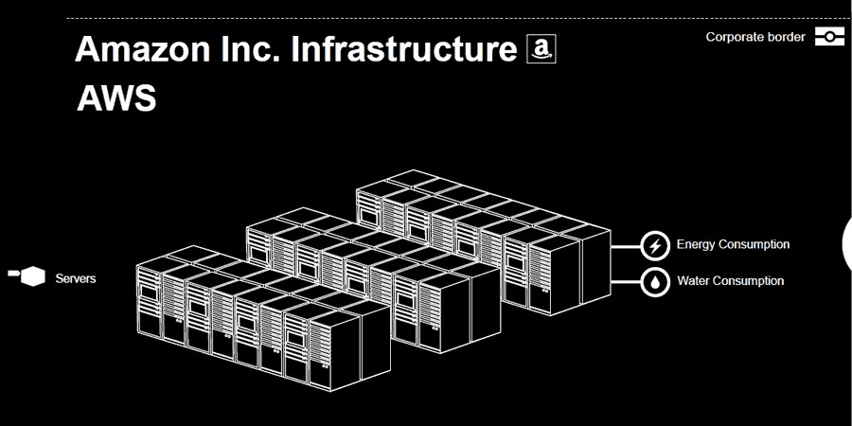

Figure 2: Servers and digital data traffic

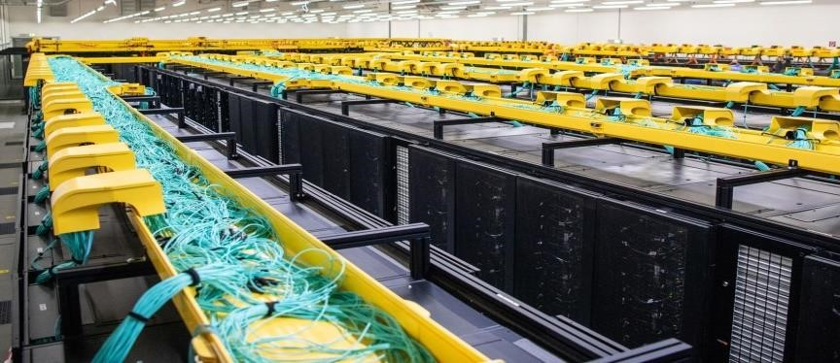

**Figure 3: Cable density in servers**

**D**

**ünyada CO**

**2**

**SALINIMI**

**Which in the world**

**Ways**

**CO**

**2**

**Swinging?**

**%**

**Electricity generation**

**42**

**Transportation**

**)**

**Tools**

**(**

**24**

**industry**

**)**

**production**

**(**

**19**

**building**

**(heating)**

**8**

**miscellaneous**

**7**

|  |
| --- |
|  |

**By energy sources**

**,**

**e per kWh**

**lektrik üreti**

**lirken**

**atmospheres**

**Oscillating**

**CO**

**2**

**gram) quantity**

**(**

**lar**

**I**

**lignite**

**980**

**-**

**1230**

**NUCLEAR POWER PLANT**

**(**

**uranium**

**)**

**:**

**16**

**-**

**23**

**TAŞKÖMÜR**

**790**

**-**

**1080**

**WIND : 8**

**-**

**16**

**PETROL**

**890**

**WATER (DAMS) : 4**

**-**

**13**

**Natural gas**

**640**

**FOTOVOLTA-K**

**80**

**-**

**180**

**Here are a few examples of the amount of electricity andco2** released by **the Internet:**

1. Google estimates that on **average, 50,000 questions** are asked every second, which releases approximately **500 grams of CO2** into the air every second.
2. With its Annex, 1 Megabyte (1MB) email causes electricity to be used for half an hour of a 60W bulb during its total life, while up to 20 grams of **CO2** are released into the air.
3. Writing 20 emails every day for 1 year is equivalent to **co2**emissions that will be released when a car travels 1000 km.
4. The amount of **CO2**released into the air as a result of electricity used during the search of a web page and the discovery of 5 addresses, for example, is 10 grams.
5. The average internet user uses as much as 365 kWh of electricity throughout the year, and as a result, the amount of **CO2** released into the air is equivalent to the amount to be released when driving 1400 km by car.
6. Since the internet network and servers are designed for the most intensive use of the day, they are kept on hold at any time. That's why they use too much electricity. For example, a router usually operates at 60% capacity, but uses electricity when not in use. These usually don't have on-off buttons.
7. Apps installed on mobile phones are constantly getting a lotor renewing, while billions more people use more electricity, causing **CO2** emissions. The same goes for the increasingly Twitt and the revamped facebook, instagram and a wide variety of portals. Adding to these the increasingly billions of chads, writingsand comments, the size of the electricity used and the amount of **CO2** released is predictable.

**What can we do for less electricity usage and**CO2  **emissions?**

What we can do as one of the billions to reduce both the electricity requirement and the amount of **CO2** released into the air may be to use the internet more consciously. **What are these?**

* 1. Reduce the number of emails and attachments, pictures, videos in each email, and send them by reducing loadMB files (ZIP)
  2. Type links instead of email attachments (this will prevent us from sending attachments unnecessarily that not everyone will open)
  3. Not sending chain emails, pictures, videos to many people (not forwarding)
  4. Delete non-important emails, empty mailboxes, or store them on your own PC or USB
  5. Exiting continuous and unread news message channels
  6. Destroy programs running in the background using the optimization ofsmartphones
  7. Not to buy new tools (smartphones, tablets, etc.), but to continue to use them by replete or fix their batteries (each new tool means increasing electricity generation and producing greenhouse gases)
  8. Desktop computer instead of, for example, laptopuse white. A laptop requires 75% less materials to build and 70% less electricity in its use.
  9. Using a PC to look only at internet searches and emails, tablets instead of laptops, and an e-reader to read books will reduce both the electrical ureateam and **CO2** emissions.
  10. To teach our children to use the internet consciously at home and in schools, to encourage them to play on playgrounds instead of playing on the internet. This will also reinforce friendship andreduce the growing trend of obesity in gthy thrust.

**result**

**We must consciously use the internet, which is now a part of our lives, which provides us with great opportunity, to meet our real needs. We must not forget the fact that extravagance on the Internet is more 'electricity generation' and more 'CO2**  **emissions'.**

**Related resources:**

1. [Dr. Ralph Hintemann (Expert for the Federal Ministry of Economics and Energy)](https://www.borderstep.de/team/dr-ralph-hintemann/)
2. [. Stobbe, L. et al.: Development of ICT-conditional electricity demand in Germany](https://www.bmwi.de/Redaktion/DE/Downloads/E/entwicklung-des-ikt-bedingten-strombedarfs-in-deutschland-abschlussbericht.html)  [-](https://www.bmwi.de/Redaktion/DE/Downloads/E/entwicklung-des-ikt-bedingten-strombedarfs-in-deutschland-abschlussbericht.html)  [Study](https://www.bmwi.de/Redaktion/DE/Downloads/E/entwicklung-des-ikt-bedingten-strombedarfs-in-deutschland-abschlussbericht.html)   [commissioned by the Federal Ministry of Economics and Energy (Fraunhofer IZM and](https://www.bmwi.de/Redaktion/DE/Downloads/E/entwicklung-des-ikt-bedingten-strombedarfs-in-deutschland-abschlussbericht.html)  [Borderstep Institute, 2015)](https://www.bmwi.de/Redaktion/DE/Downloads/E/entwicklung-des-ikt-bedingten-strombedarfs-in-deutschland-abschlussbericht.html)
3. First overview of the CO2 balances of various energy sources. (Source: Süddeutsche Zeitung of 08.03.2007, http://www.sueddeutsche.de/wissen/arti kel/867/104763/).
4. [Aslan, Joshua et al.: Electricity Intensity of Internet Data Transmission: Untangling the Estimates (Journal of Industrial Ecology, 2018)](https://onlinelibrary.wiley.com/doi/full/10.1111/jiec.12630)
5. [The World Factbook (Central Intelligence Agency, 2018)](https://www.cia.gov/library/publications/the-world-factbook/rankorder/2233rank.html)
6. [Achieving Our 100% Renewable Energy Purchasing Goal and Going Beyond (Google, 2016) (PDF)](https://static.googleusercontent.com/media/www.google.com/de/green/pdf/achieving-100-renewable-energy-purchasing-goal.pdf)
7. [Hintemann, Ralph et al.: Green Cloud? The current and future development of energy consumption by data centers, networks and end-user devices (Borderstep Institute, 2016) (PDF)](https://www.borderstep.de/wp-content/uploads/2016/09/ICT4S-Hintemann-Clausen-Green-Cloud-final-2016.pdf)
8. [Proceedings of ICT for Sustainability 2016 (Atlantis Press)](https://www.atlantis-press.com/proceedings/ict4s-16)
9. [Energy](https://www.borderstep.de/projekte/smarte-rahmenbedingungen-impulspapier-bund/)  [and resource savings for connected products (Borderstep Institute](https://www.borderstep.de/projekte/smarte-rahmenbedingungen-impulspapier-bund/)  [for Innovation and Sustainability, 2018)](https://www.borderstep.de/projekte/smarte-rahmenbedingungen-impulspapier-bund/)
10. [https://www.energuide.be/en/questions-answers/do-i-emit-co2-when-i-surf-theinternet/69/](https://www.energuide.be/en/questions-answers/do-i-emit-co2-when-i-surf-the-internet/69/)
11. World Energıe Agency (internet)
12. World Nuclear Organisation (internet)
13. [https://www.bundestag.de/resource/blob/406432/70f77c4c170d9048d88dcc3071b7721c/w d-8-056-07-pdf-data.pdf](https://www.bundestag.de/resource/blob/406432/70f77c4c170d9048d88dcc3071b7721c/wd-8-056-07-pdf-data.pdf)